



**ZOO**

**PROJECT GROUP MEMBERS**

|  |  |
| --- | --- |
| **Students Id** | **Student Name** |
| **Student1362459** | **Muhammad Talha** |
| **Student1362458** | **Muhammad Huzaifa Fazil** |
| **Student1361612** | **Roshaan Bin Abid** |

**CURRICULUM BATCH**

**7062 2201F2**

# FACULTY

**SYED HARRIS AHMED**

# CO-ORDINATOR

**SIDRAH SALEEM**

**SCREENSHOTS**

**OF**

**E-PROJECT**

# Homepage

When users open our website, they will see this user-friendly home page.

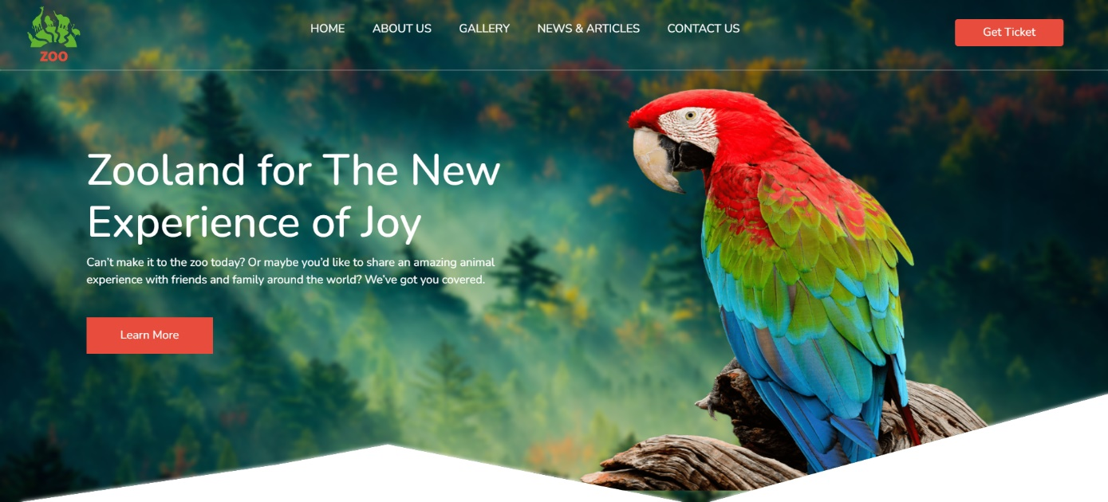

# Mid Homepage

Our Mid homepage includes animal image animations

And popular packages

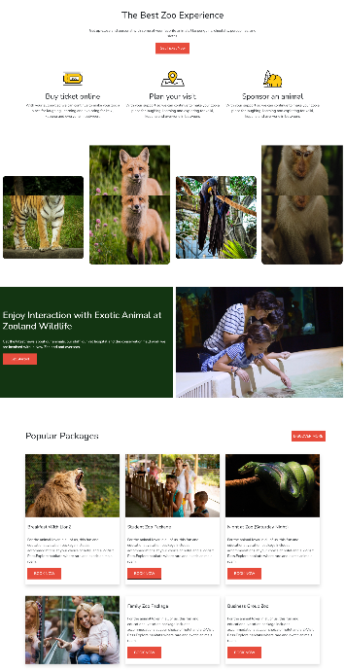

# About Us

About us shows some details of zoo organization.

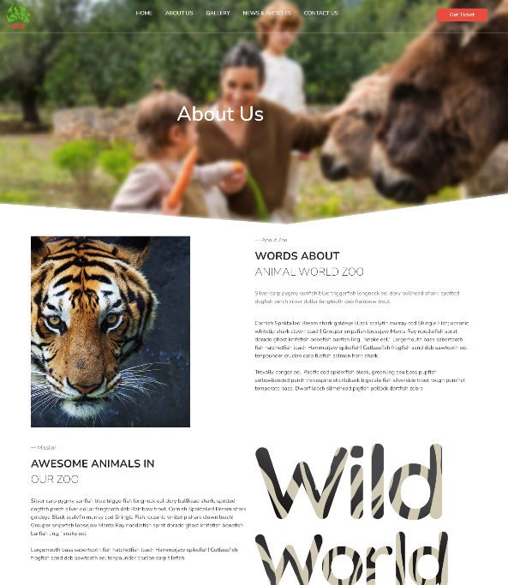

# Gallery

In gallery includes images of zoo animals with hover effects

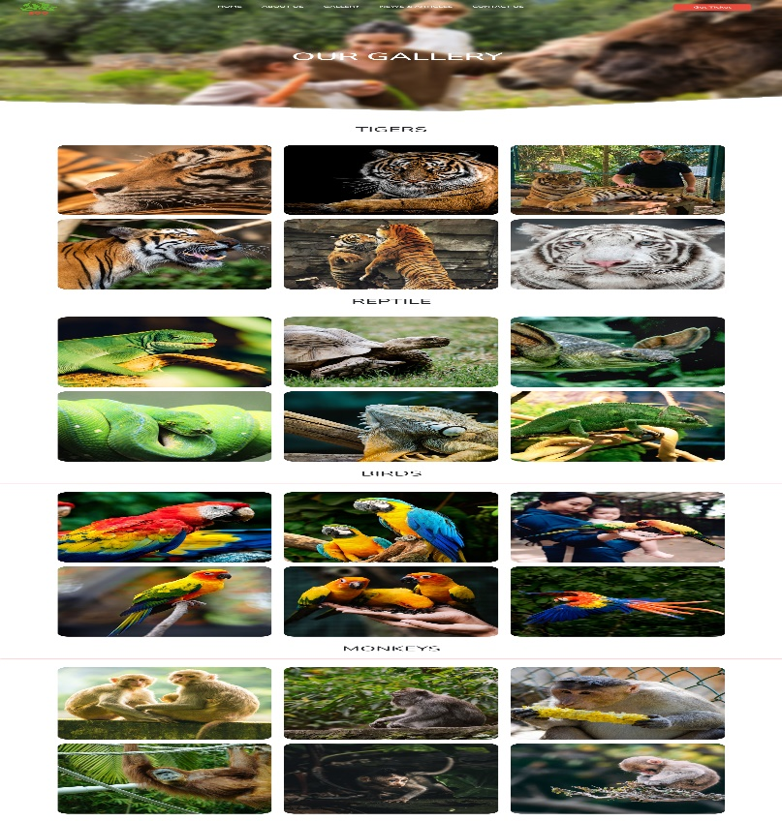

# News And Articles

In news and articles, users can see different types of news and various articles about animals and zoo

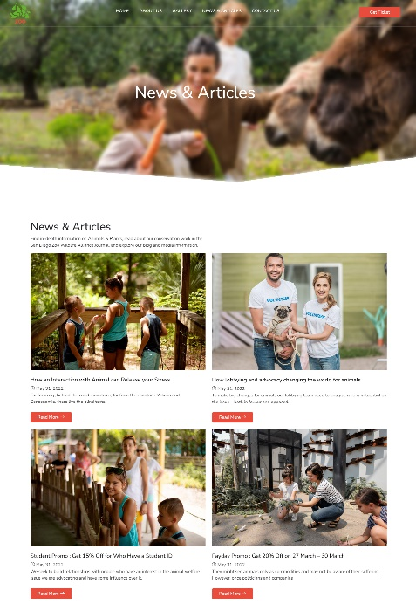

# Article 1:Release your stress

In this article, you can see how interaction with an animal can release your stress

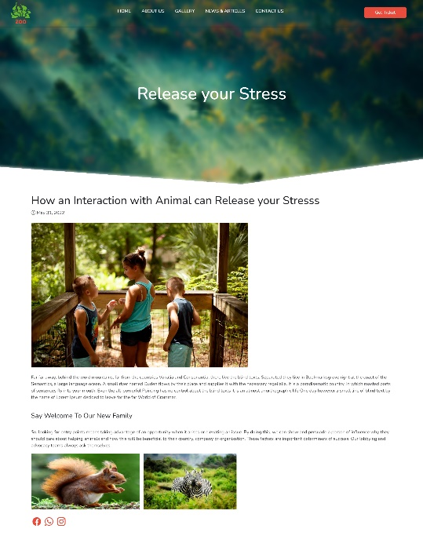

# Articles 2:World For Animal

In this article, you can see how lobbying and advocacy changing the world for animal

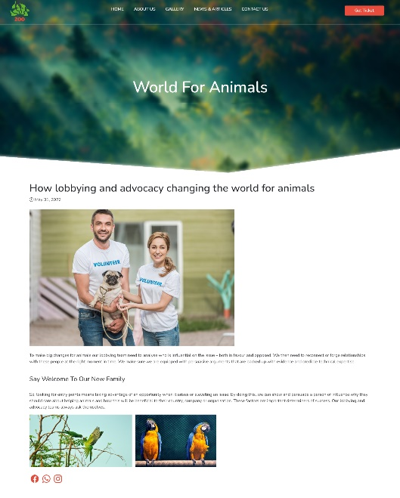

# Articles 3:Payday Promo

In this article, you can see payday promo get 20% off

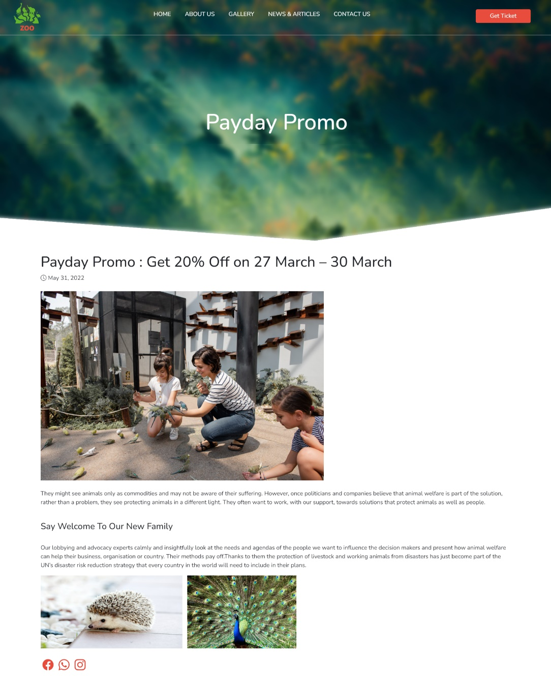

# Articles 4:Student Promo

In this article, you can see a student promo get 15% off

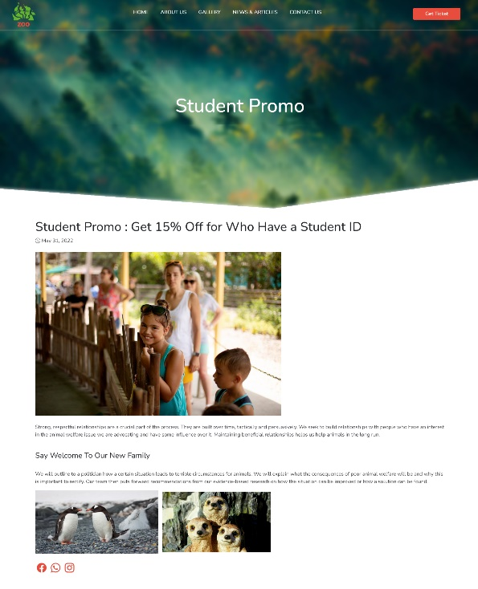

# Contact Us

Users can contact us if they had any issues in placing an order.

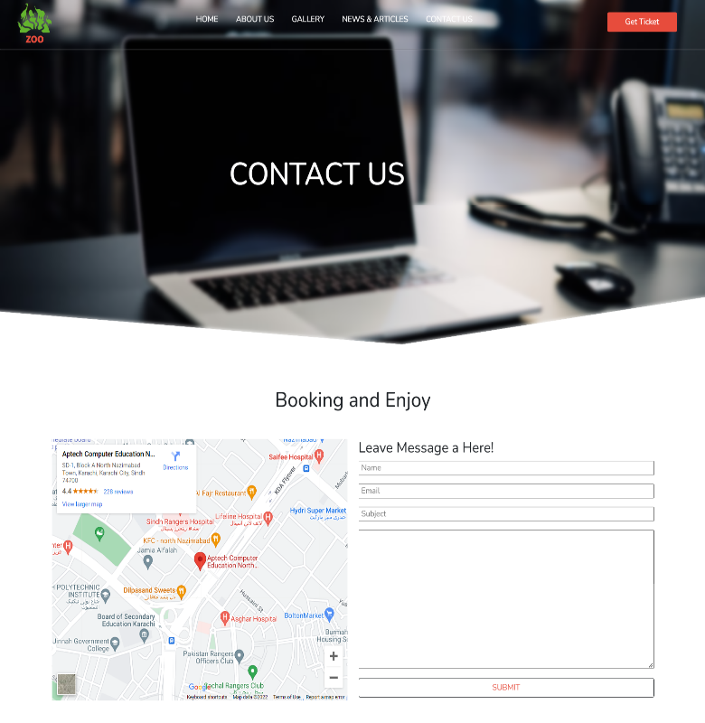

# Get Ticket

Users can easily Booked their Ticket from this place.

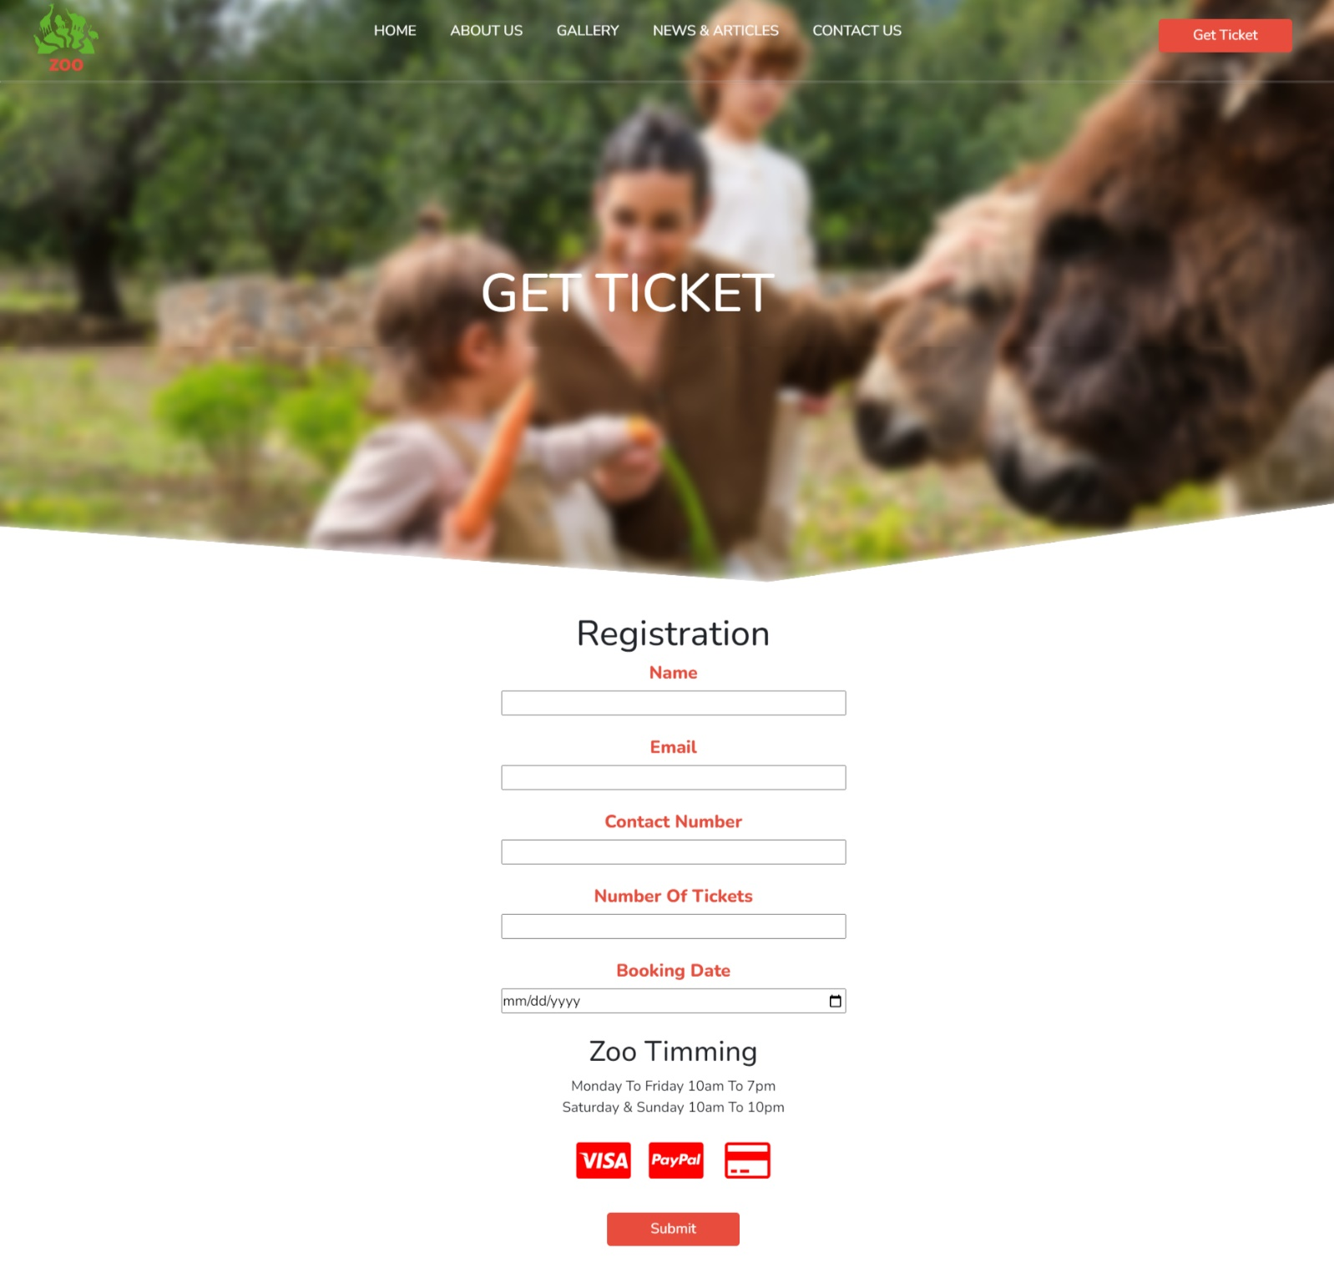

# Footer

At the end of the website, users can see this footer which has some links.

­­­ 